Detailed design and Approach:

<http://localhost:8080/FlagPicker/documentation/>

Technology Stack used

[1] Spring Web MVC

[2] Spring REST API

[3] Swagger API

[4] Spring Profile Concept

[5] Custom Cache Builder

i. Demo implementation using in-memory look up

ii Spring Data JPA implementation

[6] Global Exception Handler (Controller Advice Spring AOP)

[7] Junit using Mokito

[8] Interface Based implementation

REST API Documentation:

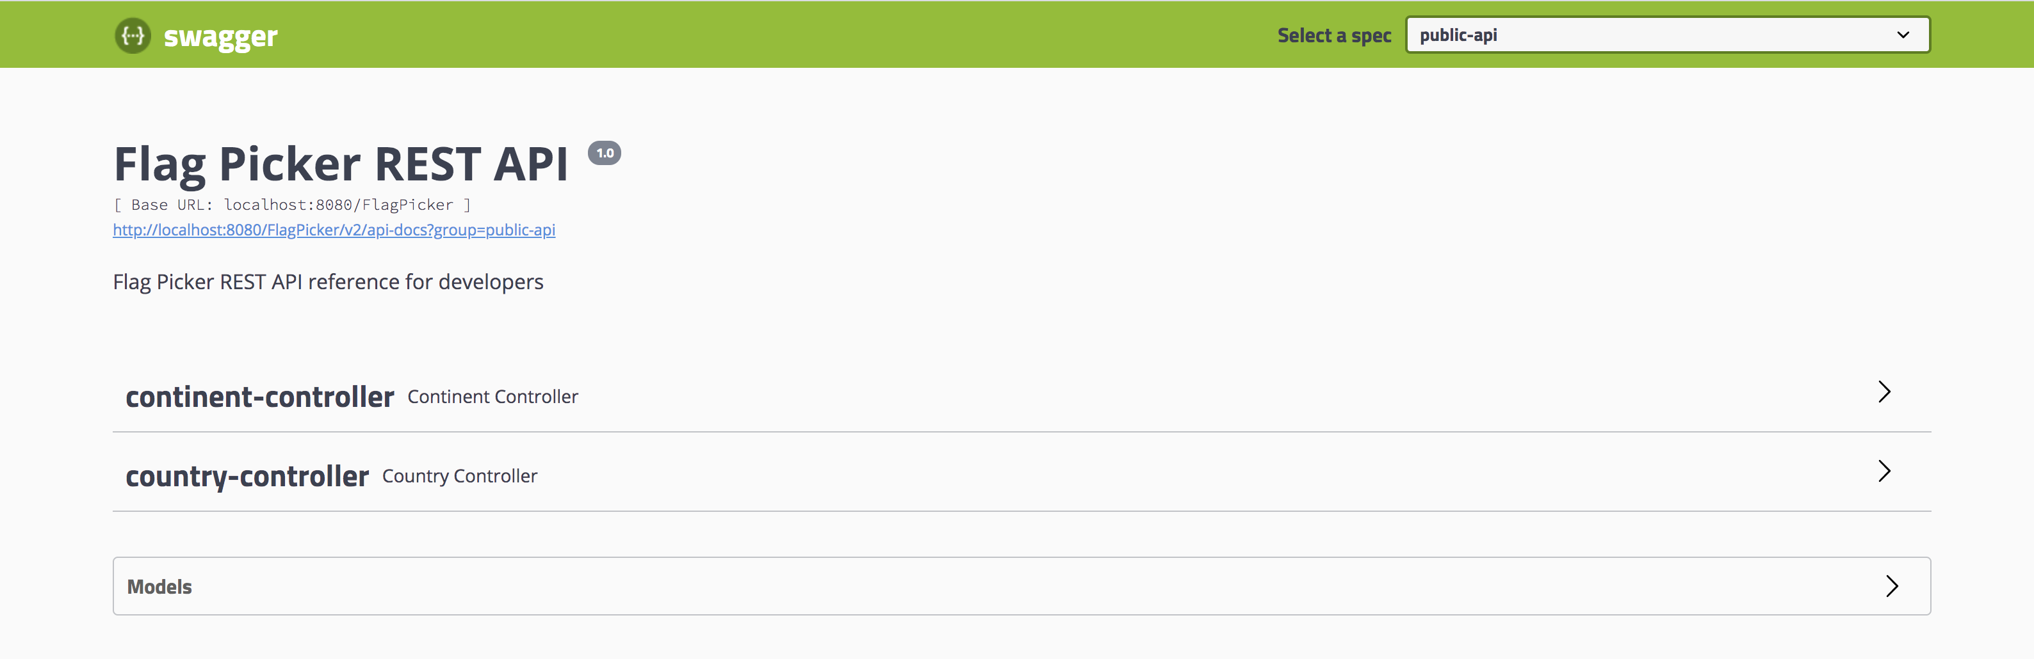

Fetch all [continents](http://localhost:8080/FlagPicker/swagger-ui.html#/operations/continent-controller/getContinentsUsingGET) -

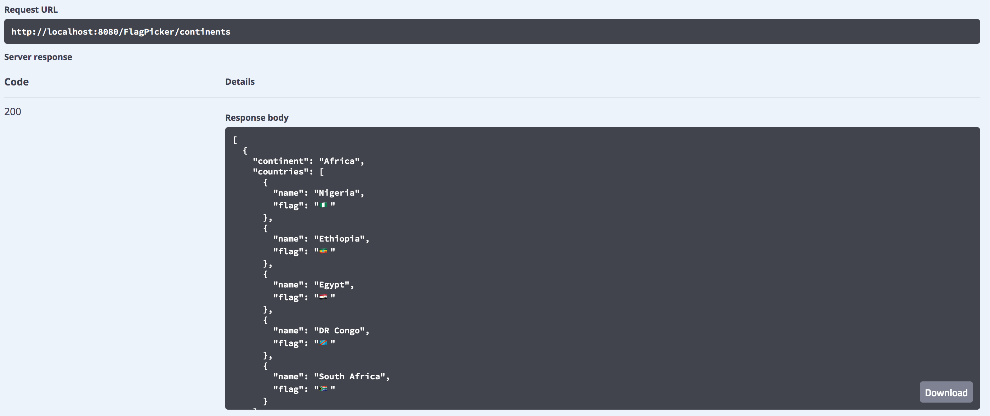

Fetch all [continents](http://localhost:8080/FlagPicker/swagger-ui.html#/operations/continent-controller/getContinentsUsingGET) For given Value -

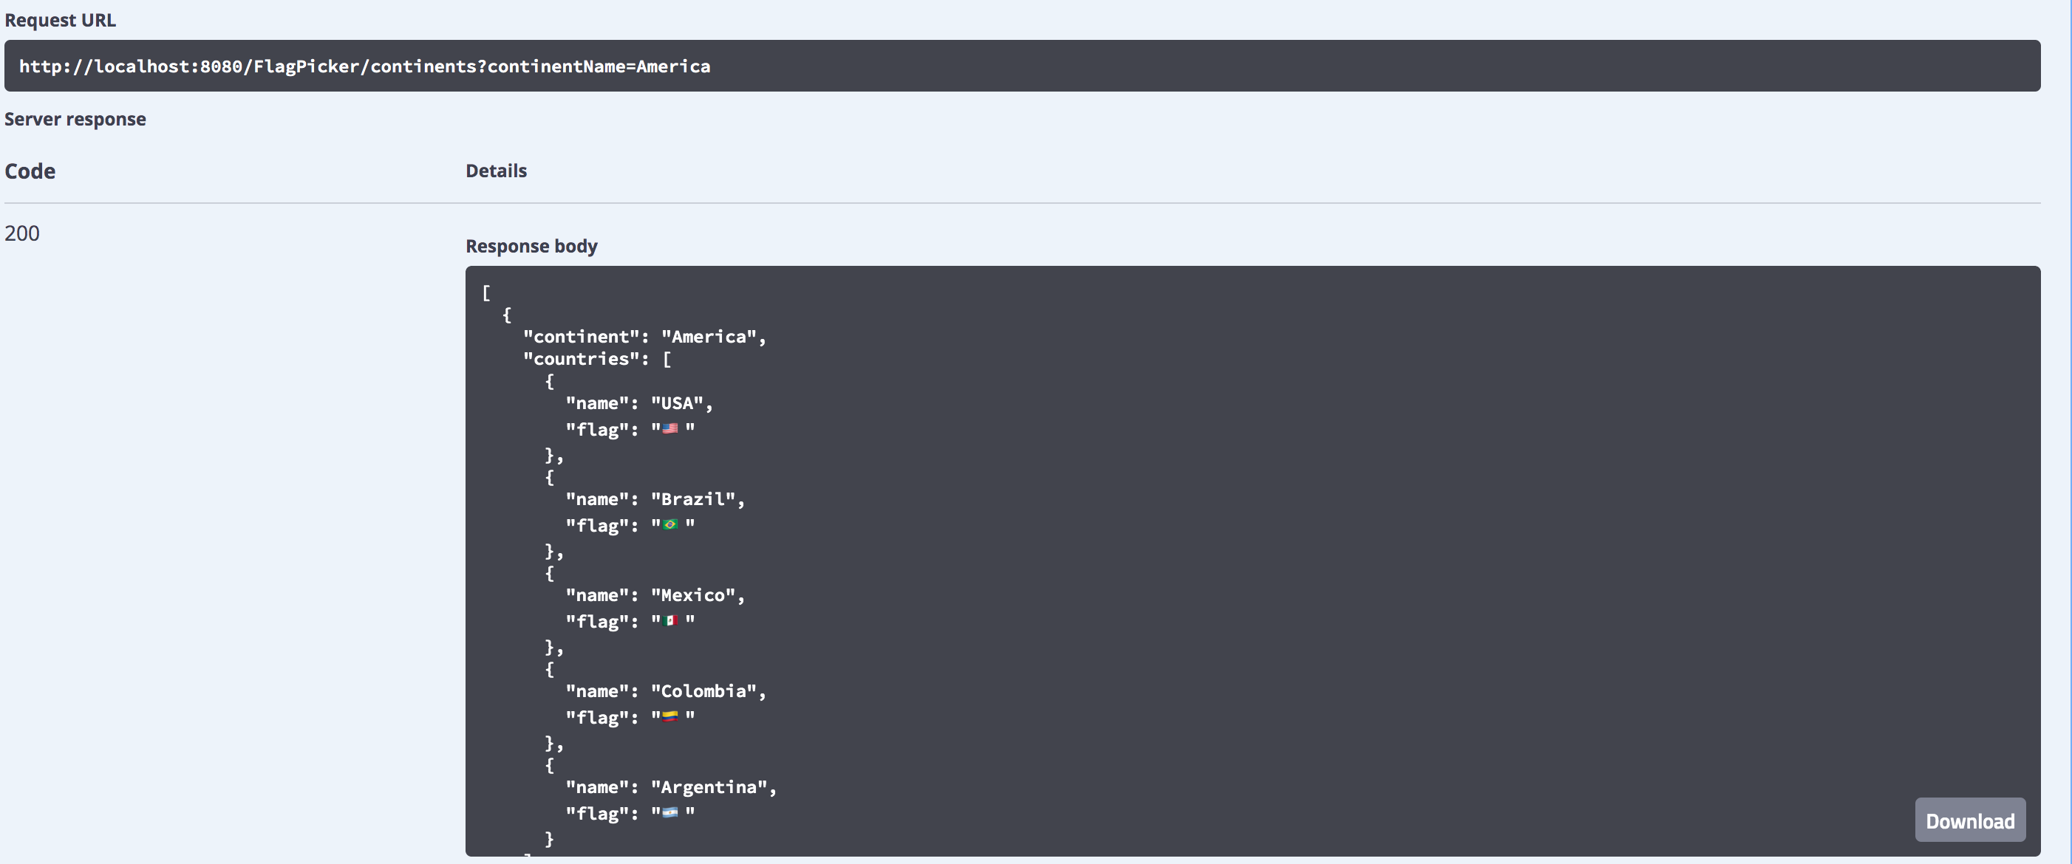

Find all country for give continent Name: -

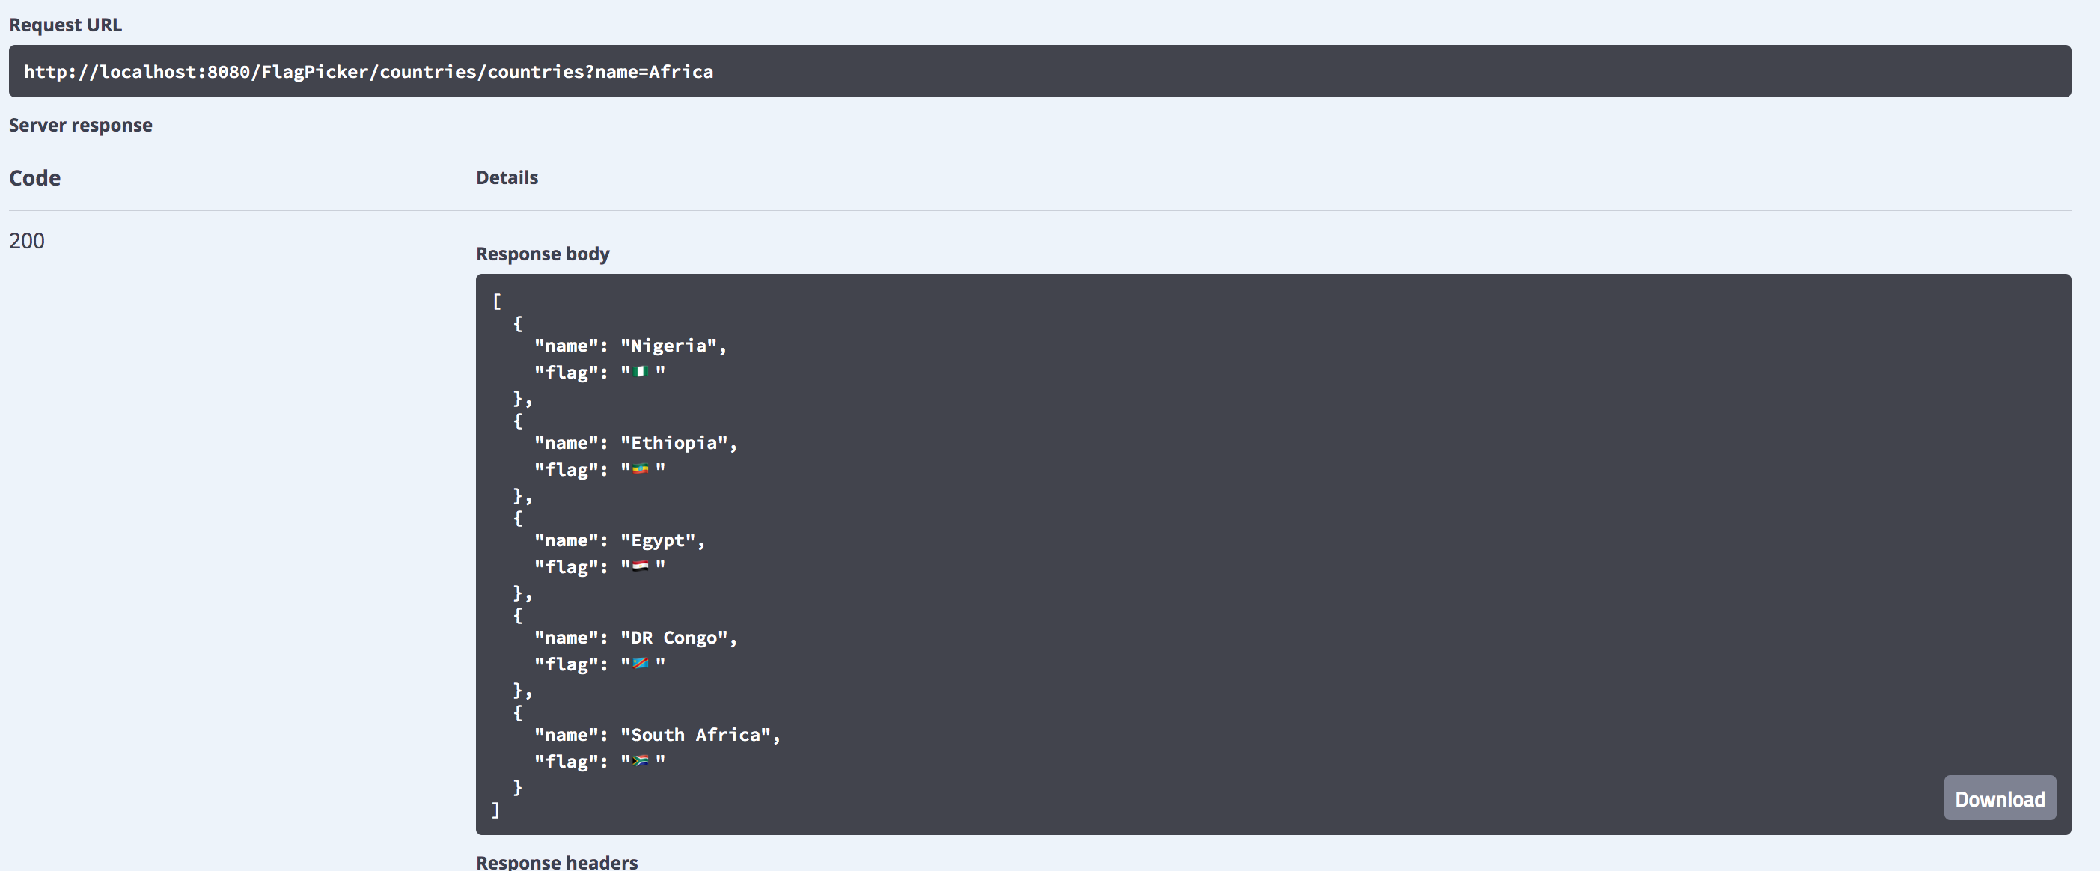

Find Flag for given country:

